**Teaching Statement**

My teaching philosophy originates from my passion for education in the clinical and academic settings. My main goals as an educator are to make students capable to critically think and appraise various forms of knowledge and training, to engage into life-long learning and to act with integrity and respect as future leaders in our community. During my early years of my university life, I admired my professors who were able to deliver detailed information and/or complex concepts in an interactive and enjoyable way, that facilitated more effective learning. I had the opportunity to be exposed to numerous skilled professors in various fields of exercise physiology, physiotherapy, and clinical epidemiology. By observing their different approaches (i.e., assignments relevant to profession, hands-on learning, group projects) and reflecting on which things enhanced my own learning, I came to appreciate the need for different strategies for different types of material or learners. I appreciate that each student has different learning needs and goals, that may require a universal design of learning approach. My teaching approach will involve a case-based approach that engages students in discussion of specific scenarios that resemble real-world examples. I firmly believe that a learner-centered approach will have an intense interaction among the students by building their knowledge and by working together to examine the case. My teaching philosophy has 3 critical elements: 1) to develop a clear set of expected teaching outcomes and mapping the teaching strategies to those outcomes 2) to develop an array of engaging teaching resources 3) to ensure ongoing evaluation including formative and summative feedback that can be used by students to monitor their learning progress.

My teaching experience started in 2010 when I was enlisted as trainer for Special Forces military personnel where I was responsible for the daily training of military personnel. As an instructor I was responsible for the daily instruction of new recruits on how to perform exercises effectively in a safe manner without sacrificing their formation. From this experience I learned how to structure sessions, maintain schedules/order and provide clear instructions.

My clinical academic teaching experience started in 2015 with supervision and clinical instruction in PT 9524x: Physical Therapy in Community Settings at the School of Physical Therapy at Western University. I served for 2 years under the supervision of Dr. Denise Connelly. This was a mandatory course for second year Master of Physical Therapy students enrolled in Western University’s entry-to-practice program. I had a variety of responsibilities, ranging from organizing the lectures and lab sessions, to collaborating with my co-instructors to provide fidelity in how we delivered the concepts in a clear and concise manner. The course was designed to introduce students to the most common conditions of neurological, cardiorespiratory, and musculoskeletal systems seen by physiotherapists working in community settings. Case vignettes were utilized to augment theoretical knowledge and provide opportunities to integrate theoretical knowledge into practical scenarios. My role was to facilitate skill acquisition and identify effective learning strategies. Through this experience, I became more familiar with the curriculum, faculty and learning strategies that support the professional program in Physical Therapy.

My approach to graduate supervision presumes that by providing strong methods training, ongoing feedback, and excellent project opportunities to trainees, I can support their development as researchers. In early 2019, I recruited and mentored two graduate students for the development of an evidence synthesis protocol during their graduate studies at McGill University. I also served as a first point-of-contact mentor for a fourth-year undergraduate student at the Hand and Upper Limb Centre. We collaborated in an independent research project in which I guided the student to prepare the protocol for a measurement study and submit ethics. I supervised 2 separate groups of physiotherapy students to conduct independent projects, which led to peer review publications in BMJ Open.

Currently, as a postdoctoral fellow I am assisting in a graduate course at the Department of Clinical Epidemiology and Health Care Research at University of Toronto. I have multiple administrative and teaching assistant responsibilities such as helping students to operate the necessary software, ensure that they follow the latest reporting guidelines and marking their assignments. I engage in multiple strategies to improve my abilities as an educator. This includes taking on multiple opportunities to engage in classroom teaching or participating in service roles that support education, ensuring I have a strong and current toolbox of epidemiologic/biostatical methods to pass on, and that I seek ongoing feedback to improve my teaching abilities.

I am confident my research program will attract both international and domestic students from different fields that will benefit the Faculty of Health Sciences at Western University. As a doctoral student I was able to motivate my peers to participate in several research studies by make them feel that research is easily accessible and rewarding. To elicit my peers’ participation in research, I emphasized how rewarding my own research activity was and how different experiences were essential to our personal growth of our profession.

My research program will incorporate innovative approaches and online technologies designed to enhance learning in the graduate context such as interactive videos with real time examples how to conduct research and interactive discussion groups for problem solving. To attract students my research lab will highlight annually students’ success stories to help prospective students picturing themselves in our institution to conduct research. My experience from 4 different universities so far, indicated that student success stories are the most influential in their decision to conduct research. I will encourage prospective students to contact current students and ask them to describe their experience to support an open inviting research program. I believe that my research program in the musculoskeletal field will attract the next generation of researchers and clinicians to work with me and result in knowledge translation. However, these fields have many interesting methodologic complexities that require use of emerging methods. I think my ability to appreciate these issues and experience working in diverse fields with questions ranging from surgery, rehab to the pandemic will allow me to relate to learners in rehabilitation sciences who will come from different and diverse backgrounds. Having worked with excellent mentors, I know the importance of engagement and customized learning in a cross-cultural environment. I hope to provide adaptive and engaged mentorship and excellent learning opportunities for people as I take on an educational role.

**Example of Sample Course Material**

**Syllabus**

Course Title: Management of Covid-19

Course Duration: 6 weeks

Course Coordinator: Dr. Pavlos Bobos PT, PhD

**Course Description**

The course will cover the role of physiotherapy in COVID-19, how to treat patients within the framework of professional training in physical therapy and what are the best interventions at the different severity stages of COVID-19. The course will also cover the area of post COVID-19 syndrome, in terms of the prevalence of long-term COVID-19 symptoms, and how physiotherapists can address these symptoms.

**Learner Objectives**

1. To introduce the epidemiology and clinical history of covid-19

2. To develop theoretical knowledge on basic disease outbreak patterns with an emphasis on pandemics

3. To introduce the different severity stages of Covid-19 and the role of rehabilitation in each stage.

4. To develop an evidence-based approach for assessing and addressing Covid-19 symptoms in a hospital setting (ICU care included)

5. To be able to recognize post covid-19 syndrome based on both short-term and long-term symptoms, and develop a therapeutic protocol accordingly

**Course Lectures**

|  |  |
| --- | --- |
| **Session** | **Description** |
| 1. Introduction | Introductory summary of the course material |
| 2. SARS-CoV-2 infection, Covid-19 Disease, Epidemiology | Disease Outbreak patterns, Pandemic Definition, Attack Rate, R number, Public Health Measures |
| 3. Severity stages, Assessment, Management | Role of physiotherapy in different severity cases (mild infection, hospitalized, low/high flow oxygen, mechanically ventilated) |
| 4. Acute care Management | Oxygen support (flow rates), breathing exercises, positioning, approach to minimize infection |
| 5. ICU care Management | Ventilators, gas exchange values, minimize infection, suction indicators, positioning, approach to minimize infection |
| 6. Post Covid 19 Syndrome | Prevalence, short-term & long-term symptoms, Assessment, Interventions |

**Teaching Methodology**

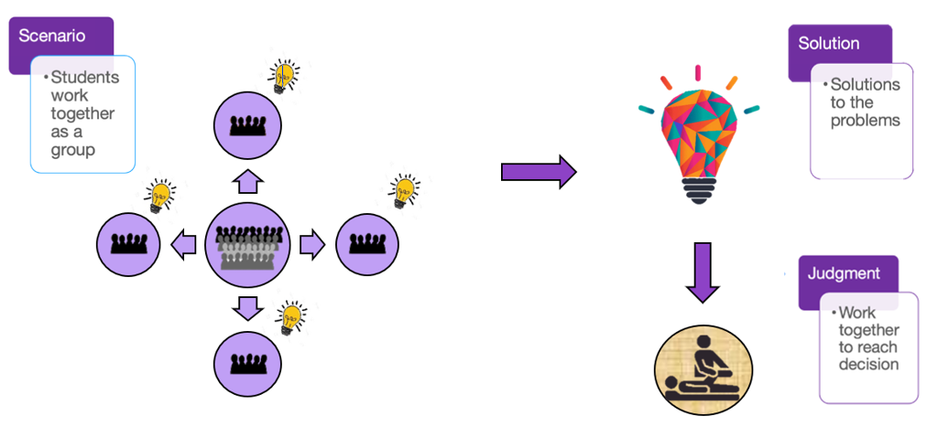

My teaching approach will involve a case-based approach that engages students in discussion of specific scenarios that resemble real-world examples. I firmly believe that a learner-centered approach will have an intense interaction among the students by building their knowledge and by working together to examine the case. Through group-based critical discussion, students will develop their communicational skills and improve their critical thinking to provide evidence-based solutions to the problem. The different approaches will then be presented, discussed and synthesized to reach a decision. The goal is to get each student actively involved to the learning process and stimulate their personal growth. This way, I intend to enhance their confidence and help them to develop a broad mindset that will challenge the pre-established knowledge, with the goal to provide high quality care based on science, patient preferences and clinical expertise.

**Course Evaluation**

**The final mark is composed of:**

50% Group assignment (30% written report, 20% case presentation)

50% Final assessment

**Group assignment**

The group assignment would be to develop a critical report around the therapeutic management of a case of clinical interest. Each group will be randomly pre-assigned to a case. The written report will be limited to a maximum of 2500 words. Each group will have 10-15 minutes to present their case.

**Grading Scale for Group Assignment**

|  |  |
| --- | --- |
| **A+ 90-100%** | Exemplary range and depth of attainment of intended learning outcomes, secured by discriminating command of a comprehensive range of relevant materials and analyses, and by deployment of considered judgement relating to key issues, concepts and procedures. |
| **A 85-89%** |
| **A- 80-84%** |
| **B+ 77-79%** | Conclusive attainment of virtually all intended learning outcomes, clearly grounded on a close familiarity with a wide range of supporting evidence, constructively utilised to reveal appreciable depth of understanding |
| **B 73-76%** | Clear attainment of most of the intended learning outcomes, some more securely grasped than others, resting on a circumscribed range of evidence and displaying a variable depth of understanding |
| **B- 70-72%** | Acceptable attainment of intended learning outcomes, displaying a qualified familiarity with a minimally sufficient range of relevant materials, and a grasp of the analytical issues and concepts which is generally reasonable, albeit insecure |
| **FZ 0-69%** | No convincing evidence of attainment of intended learning outcomes, such treatment of the subject as is in evidence being directionless and fragmentary |

**Final assessment**

The final assessment will be in the form of a clinical competency examination. Each student will be presented with a clinical case and will be expected to present adequate knowledge of clinical assessment and therapeutic management

**Evaluation Assessment Tool**

Assessment will be performed by using the Case History Assessment Tool (CHAT). 1 The CHAT contains 45 assessment items that utilize a 5-point Likert scale with narrative descriptors assigned to ratings 1, 3 and 5. The narrative descriptors were specifically worded to reflect the domain(s) of clinical reasoning being represented by the short-answer question. A rating of 3 on the 5-point Likert scale indicates a passing grade for all items in the assessment rubric.1

References:

1. Yeung E, Kulasagarem K, Woods N, Dubrowski A, Hodges B, Carnahan H. Validity of a new assessment rubric for a short-answer test of clinical reasoning. BMC Med Educ 2016;16(1):192.